4-DSD is a tool to detect the presence of delirium in persons with moderate to severe dementia
4-DSD
ITEM 1. ALERTNESS
Level of consciousness assessed with mRASS mRASS=___________  (If m-RASS score = -4 or -5 the patient cannot be assessed with the 4-DSD) |  |  |  | ❒ =0 (0 points) |  | ❒ ≠ 0 (1 point)
STEP 1 partial score ____/1
ITEM 2. ALTERED BRAIN FUNCTION
Inconsolability | - Does the patient not respond to attempts at comfort?  - Does the patient have repeated outbreaks, moans, etc? | ❒ Yes   Yes | ❒ No   No |  | ❒ At least one yes (1 point)
Unawareness | - Is the patient unaware of his surroundings, his personal effects, etc?  - Does the patient not recognize or fail to interact with his caregivers? | ❒ Yes   Yes | ❒ No   No |  | ❒ At least one yes (1 point)
Sleep-wake rhythm disorder | - Does the patient feel asleep during the stimulation?  - Does the patient sleep little during the night?  - Is insomnia present?  - Does the patient reverse the sleep/wake rhythm | ❒ Yes   Yes   Yes   Yes | ❒ No   No   No   No |  | ❒ At least one yes (1 point)
STEP 2 partial score ____/3
ITEM 3. ATTENTION
Instructions:
- Hold the image about 30 cm from the patient's face, moving it slowly to the right or left; show the 10 cards one at a time
- Show the first card (mirror) moving it slowly to the right or left, saying: "LOOK AT THE MIRROR” (it is possible to repeat the instruction only one time)
- Show the second card (image) moving it slowly to the right or left, saying: "LOOK AT THE CARD: IS IT AN ANIMAL”? Recording the answer (If the patient does not respond register as an incorrect response).
- Repeat this operation by alternating image/mirror cards until all 10 cards have been shown
Eye Contact: does the patient maintain eye contact with the examiner or with the card? |  |  |  | ❒ Yes (0 points) |  | ❒ No (1 point)
Visual tracking: does the patient follow the card with his eyes? |  |  |  | ❒ Yes (0 points) |  | ❒ No (1 point)
Propositive actions: the patient interacts with the card trying to reach it, name it or with facial expressions? |  |  |  | ❒ Yes (0 points) |  | ❒ No (1 point)
Sustained attention: how many cards does the patient react to (trying to reach them or with visual contact)?_____/10 |  |  |  | ≥8 (0 points) |  | ❒ ≤7 (1 point)
Attention/visual tracking: has the patient been attentive to most of the evaluation without stimulation (at least half of the time required for administration)? |  |  |  | ❒ Yes (0 points) |  | ❒ No (1 point)
Processing: how many animal/object cards have been correctly identified? _____/5 |  |  |  | ≥4 (0 points) |  | ❒ ≤3 (1 point)
Step 3 partial score ____/6
ITEM 4. ACUTE CHANGE OR FLUCTUATION IN MENTAL STATUS (data collected by interview with caregivers and/or operators)
- Demonstration of an evident acute change in the mental state in the last 2 weeks and still present in the last 24h (MUST BE NECESSARY PRESENT) |  |  |  | ❒ No |  | ❒ Yes (1 point)
- Fluctuating course of attention |  |  |  | ❒ No |  | ❒ Yes (1 point)
Step 4 partial score ____/2
TOTAL score____/12
A 4-DSD cut-off score ≥ 5 is indicative of the presence of delirium

4-DSD Noted Answers

Cards | Eye Contact | Visual Tracking | Propositive Action/Interaction | Identification*
1. Mirror | ❒ Yes  No | ❒ Yes  No | ❒ Yes  No | --
2. Lion | ❒ Yes  No | ❒ Yes  No | ❒ Yes  No | ❒ Yes  No
3. Mirror | ❒ Yes  No | ❒ Yes  No | ❒ Yes  No | --
4. Train | ❒ Yes  No | ❒ Yes  No | ❒ Yes  No | ❒ Yes  No
5. Mirror | ❒ Yes  No | ❒ Yes  No | ❒ Yes  No | --
6.Elephant | ❒ Yes  No | ❒ Yes  No | ❒ Yes  No | ❒ Yes  No
7. Mirror | ❒ Yes  No | ❒ Yes  No | ❒ Yes  No | --
8. Ladybug | ❒ Yes  No | ❒ Yes  No | ❒ Yes  No | ❒ Yes  No
9. Mirror | ❒ Yes  No | ❒ Yes  No | ❒ Yes  No | --
10.Flower | ❒ Yes  No | ❒ Yes  No | ❒ Yes  No | ❒ Yes  No
*Correct noun of animal or objects is not require; patient has only to indicate if the illustrated image is an animal or not.

Series of mirror cards, alternated with illustrated card reproducing animals (i.e. lion, elephant, ladybug) or various objects (i.e. train, flower). Each card is 14,5 cm long and 20 cm tall. Illustrated images are stylized, two-dimensional and colored animal/objects on white neutral background.
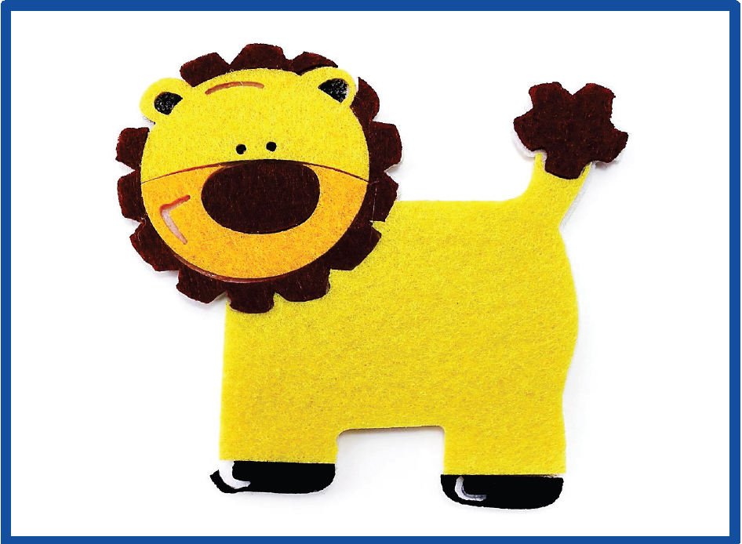

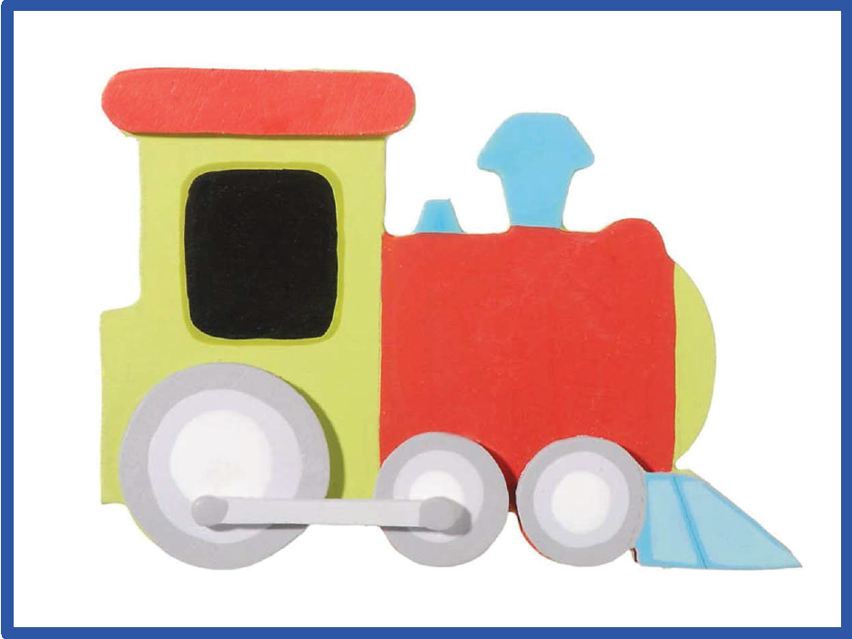
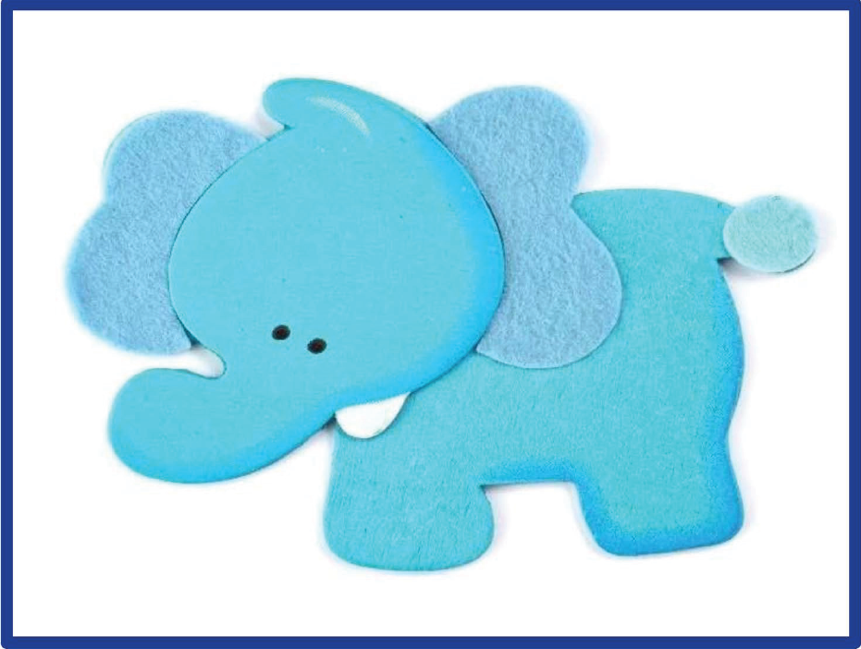

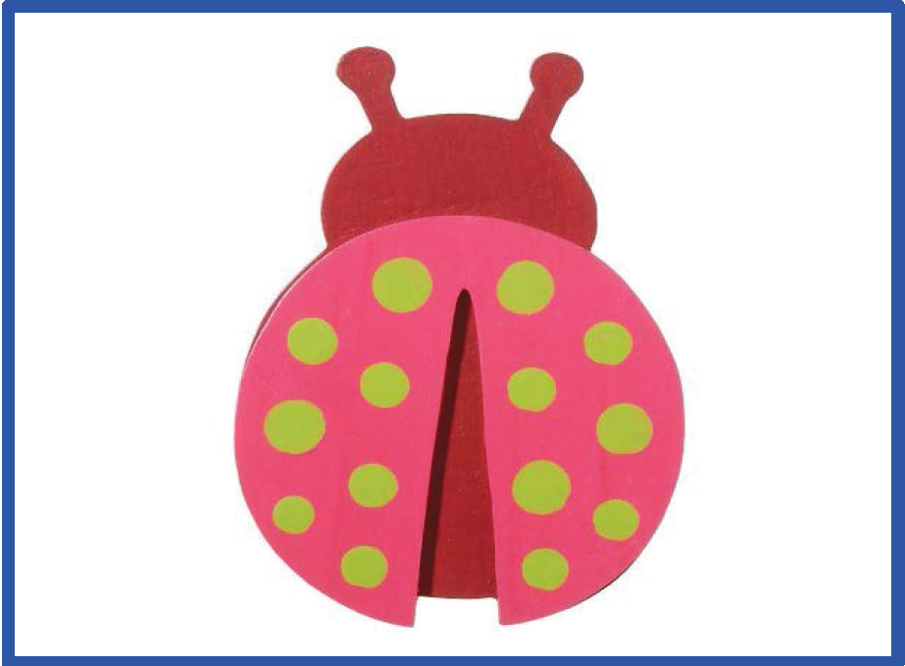
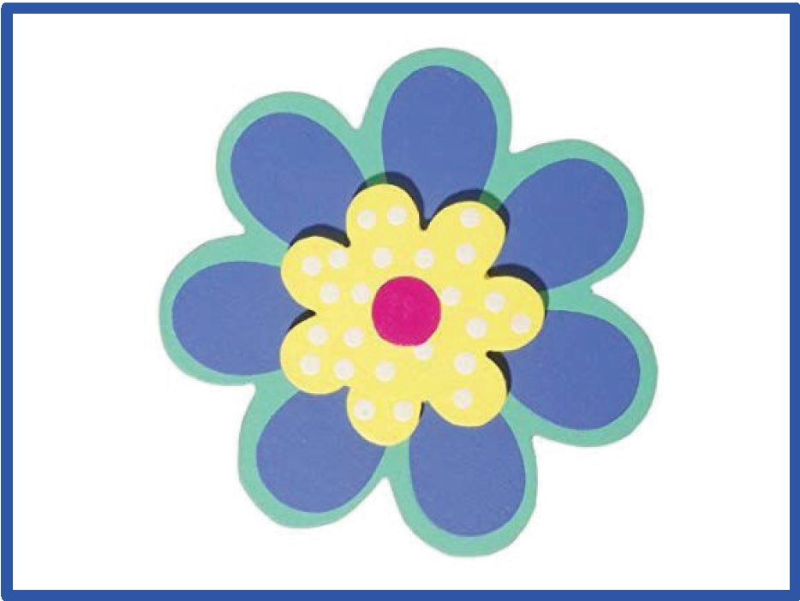

INSTRUCTIONS
The first item of the 4-DSD scale is the level of arousal measured with the Modified Richmond Agitation and Sedation Scale (mRASS) such that patients who were alert (mRASS score of 0) scoring 0 on the item and patients with any non-zero mRASS score being scored as 1.
The second item assesses the presence of altered brain function, taking into account the patient’s inconsolability, unawareness and sleep-wake rhythm alterations.
The third item of the 4-DSD assesses the level of attention. The assessor observes the patient while interacting with the test materials. The stimulus materials comprise of a series of mirror cards, alternated with illustrated cards with pictures of animals (i.e. lion, elephant, ladybug) or various objects (i.e. train, flower). Each card is 14.5 cm long and 20 cm tall. Illustrated images are stylized, two-dimensional and colored animal/objects on white neutral background. Cards are held approximately 30 cm in front of the patient, and moved slowly and randomly to the right or to the left, showing the 10 cards one at a time according to the protocol.
The fourth item of the 4-DSD assesses the presence of an acute change or fluctuation in mental status, ascertained through informant history from nursing staff and the patient's caregiver, as described in 4AT Item 4.

REFERENCE: Morandi A, Grossi E, Lucchi E, Zambon A, Faraci B, Severgnini J, MacLullich A, Smith H, Pandharipande P, Rizzini A, Galeazzi M, Massariello F, Corradi S, Raccichini A, Scrimieri A, Morichi V, Gentile S, Lucchini F, Pecorella L, Mossello E, Cherubini A, Bellelli G. The 4-DSD: A New Tool to Assess Delirium Superimposed on Moderate to Severe Dementia. J Am Med Dir Assoc. 2021 Jul;22(7):1535-1542.e3. doi: 10.1016/j.jamda.2021.02.029.

